Research Task 2

Introduction
I will work in a group, with Charlie Belton. We are going to study all the different aspects of the Right Move finance calculator, as it contains many things which I may need in my computer system. I will look at the formatting and the formulae, as well as the usability of the document.
How is the system user friendly?
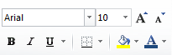
The system uses makes extensive use of formatting, which is useful both from usability and a design standpoint. The primary colour used throughout the spread sheet is blue. Blue is often referred to as a calming colour, one which can lower emotions. This works very effectively in this spreadsheet, as many people can become somewhat cross when faced with their dwindling finances. The primary method of formatting used is the formatting bar on the ribbon; it plays hosts to a number of different options, many of which are seen below. Another element that has been formatted is the sheet switcher. It has been colour coded to match all the different aspects of the calculator, and hugely improves the usability of the sheet. This design feature is also incorporated throughout the rest of the system, with each area being colour coded. This feature is immensely useful from a usability standpoint, as it allows people to easily work out which section to go to next. The usage of colours throughout the system is particularly fascinating, as it can severely affect a user’s perception. For example, the colour blue is used all the way throughout, dramatically increasing the usability of the spreadsheet, because of the correlation between the colours and the tabs. The system also transfers data from sheet to sheet, removing the need to enter data more than once. There is also a comprehensive instruction page, which does an effective job of ensuring that users know exactly what to do. Overall, the formatting used in the system, combined with the effectiveness of usability prompts, result in a very user friendly system, though the stark squares and bold colours may put some people off, as many prefer subtle gradients and very sparse use of skeumorphism, something this system has none of.
What does the system do, and who could use it?
Through a variety of formulas, the system allows people to work out their income, outcome and budget quickly and efficiently. This can be useful for a number of reasons, as many people find it difficult to work out exactly how much money they have per month. For many people, this could help avert a potential monetary disaster, as they would know exactly what to spend. With the enhanced usability of the spreadsheet, it could be particularly useful for those of a more elderly disposition, as they probably have a larger pension fund, and may need an effective way to work out how much they have.
What data does the user need to input?
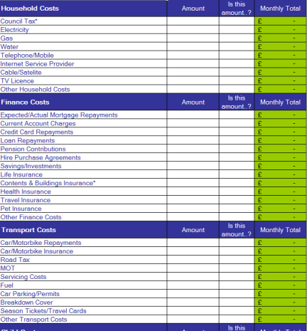
The user must input a large amount of data, as this is what the system uses to work out the user’s budget. The user needs to enter details about how much they spend on certain items, which some may find disturbing, as the less technically inclined may believe that the system is sending data to the internet, something which is of course impossible due to the lack of macros included in the system. They must input details about their monthly, quarterly or yearly income, and, with the data the user entered in on the outgoings tab, the system works out the appropriate data for the user.
Who is the system designed for?
Because of the large amount of simplistic colours, large amount of instructions, and easy wording, one can assume the system is designed for the average computer user; somebody who is perhaps less technically inclined. There are, however, certain aspects that make it seem like it was designed for a more elderly person, such as the wide use of bright, stark colours, and easy to understand vocabulary. Overall, the system is designed for distinctly middle class people, those who have a basic knowledge of ICT, but are obviously not direct descendants of Gates or Jobs.
The main formulae are IF statements.
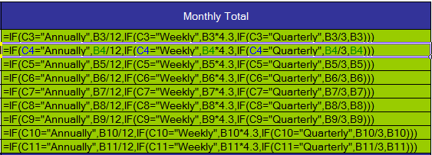

This is an example of nesting it uses multiple IF statements three to be accurate. The number of IF statements relates to the number of possible options on the previous cell. The options are monthly, weekly, annually and quarterly. It says that if you answer monthly the data is just moved across if you answer differently it does a sum to convert it in to a monthly payment/outgoing. The sum depends on what option you pick.
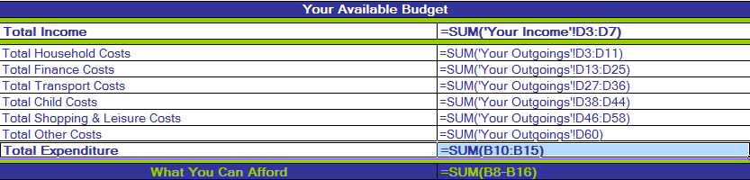
The only other example of formula is simple addition on the totals and subtractions on the final amount you can afford ^{see below} this has been used to allow the user to enter little information and get a lot back in the form of budgets. This information could be easily constructed in to a pie chart for easy readability and display for the family to view. A pie chart is not the only char that can be used other charts that could be included are bar, line, radar, bubble, surface and area graphs. If I had made the spread sheet I would have made a macro that made a set of graphs on the final page to clearly illustrate spending and budget without this feature the data is hard to understand
What features does this spread sheet use?
The spread sheet uses many features the most simple of these are sheets. Sheets must not be underestimated as they provide a clear and simple structure. The sheets are linked by formula meaning the two sheets can interact. This means that if data is changed it will change on both sheets there is no need to enter data twice. The next feature is colour coding. The income is blue as this has connotations of good. The out goings is red as these are viewed as a negative force. The budget is in green as represents nature and the fact this is in balance as you hope your budget should be. It uses an instruction page this implies it is aimed at normal people not ICT skilled people. I believe they should have used macros. Macros allow actions to be recorded and played out on demand. This means complex actions can be done by people with little ICT experience. The lack of macros I believe is an oversight by rightmove.com. Had I made this product I would have both included macros and spread the tables out. The layout is crowded this means that it is hard to keep focus and complete the whole document. They have not used conditional formatting this would help when viewing the final spending budget if the spending was higher than the final income the box could go red and warn the user of their impending doom.

